# Worksheet 4 The Turing Machine

# Task 1

1. Complete the trace table based on the state transition diagram and the tape.

Use the cards to “run the program”. Try it with different input strings. Does it always reach the halting state?

Identify the purpose of this Turing machine. What cell does the read-write head stop on?

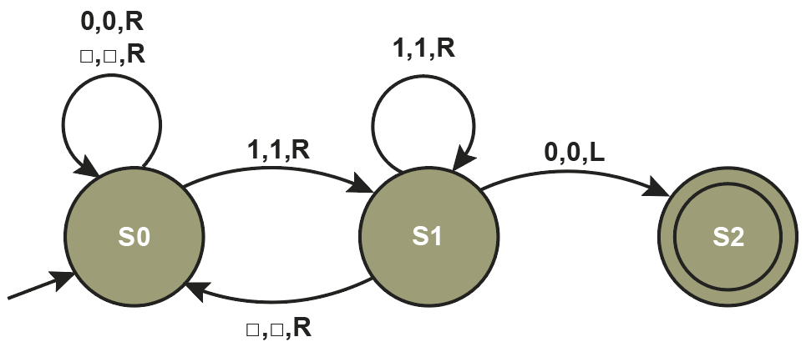

|  |  |  |  |  |  |  |  |  |  |  |  |  |
| --- | --- | --- | --- | --- | --- | --- | --- | --- | --- | --- | --- | --- |
| … | 1 | 1 |  | 0 | 1 | 0 | 0 | 1 | … |  |  | S0 |

|  |  |  |  |  |
| --- | --- | --- | --- | --- |
| **Current State** | **Input Symbol** | **Output Symbol** | **Move** | **Next State** |
| S0 | 1 | 1 | R | S1 |
| S1 | 1 | 1 | R | S1 |
| S1 |  |  | R | S0 |
| S0 | 0 | 0 | R | S0 |
| S0 | 1 | 1 | R | S1 |
| S1 | 0 | 0 | L | S2 |

Stops on 1

2. Use the cards to trace the computation of the Turing machine corresponding to the following FSM and data on the tape.

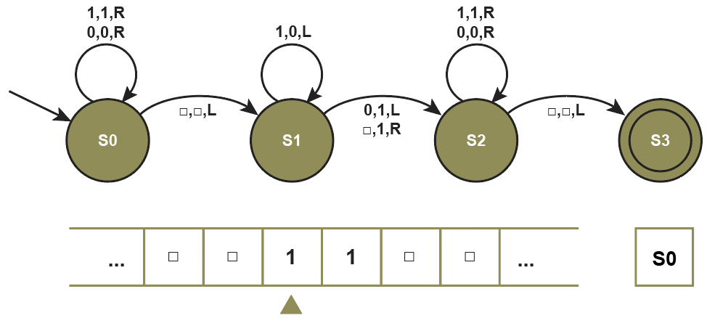

What is written on the tape after the halting state is reached?

1 1 0 0 1 1 1

Try it with data 101. What operation does the machine execute?

# Task 2

3. Write the associated transition function for the Turing machine below. The first line is done for you.



|  |
| --- |
| δ (S0, 0) = (S0, 0, R) |
| δ (S0, ) = (S0, , R) |
| δ (S0, 1) = (S1, 1, R) |
| δ (S1, ) = (S0, , R) |
| δ (S1, 1) = (S1, 1, R) |
| δ (S1, 0) = (S2, 0, L) |

4. Complete the finite state transition diagram for a Turing machine that has a transition function defined by δ where

δ (S0, 0) = (S1, 1, R)

δ (S0, 1) = (S0, 1, R)

δ (S0, ) = (S0, 1, R)

δ (S1, 0) = (S0, 1, L)

δ (S1, 1) = (S1, 1, R)

δ (S1, ) = (S2, 1, R)

δ (Current State, Input symbol) = (Next State, Output symbol, Movement).

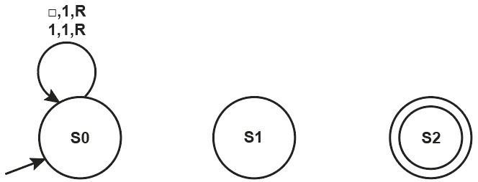



# Task 3 – Extension

5. A Turing machine has been designed with the following transition function.

|  |
| --- |
| δ (S0, 0) = (S1, , R) |
| δ (S0, 1) = (S1, , R) |
| δ (S0, ) = (S6, , L) |
| δ (S1, 0) = (S1, 0, R) |
| δ (S1, 1) = (S1, 1, R) |
| δ (S1, ) = (S2, , L) |
| δ (S2, 0) = (S3, , L) |
| δ (S2, 1) = (S4, , L) |
| δ (S2, ) = (S6, , L) |
| δ (S3, 0) = (S3, 0, L) |
| δ (S3, 1) = (S4, 0, L) |
| δ (S3, ) = (S5, 0, R) |
| δ (S4, 0) = (S3, 1, L) |
| δ (S4, 1) = (S4, 1, L) |
| δ (S4, ) = (S5, 1, R) |

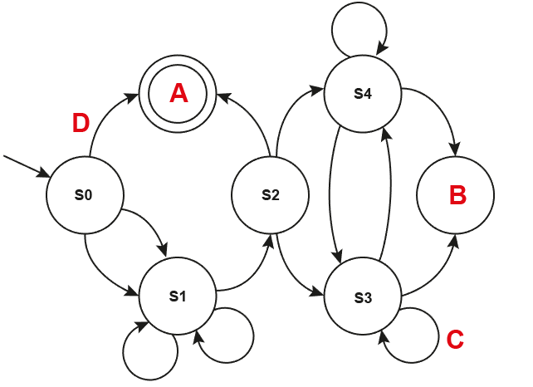



Here is a partially complete state transition diagram for this Turing machine.

1. Complete the diagram, labelling all states and transitions
2. Which state is indicated by the label A?
3. Which state is indicated by the label B?
4. What is the transition label for the arc at C?
5. What is the transition label for the arc at D?
6. The first row in this table represents the tape contents, starting point for the read-write head and the current state. The current state is indicated by the * symbol. Complete the trace table to show the behaviour of the program.

|  |  |  |  |  |  |  |  |  |  |
| --- | --- | --- | --- | --- | --- | --- | --- | --- | --- |
|  |  |  |  |  |  |  |  |  | **Current state** |
|  | 1 | 0 * | 1 | 1 |  |  |  |  | S0 |
|  |  |  |  |  |  |  |  |  |  |
|  |  |  |  |  |  |  |  |  |  |
|  |  |  |  |  |  |  |  |  |  |
|  |  |  |  |  |  |  |  |  |  |
|  |  |  |  |  |  |  |  |  |  |
|  |  |  |  |  |  |  |  |  |  |
|  |  |  |  |  |  |  |  |  |  |
|  |  |  |  |  |  |  |  |  |  |

1. What is the function of this Turing machine?
2. Why is State 3 not visited in this scenario?